BACKGROUND
In order to support efforts to achieve the first 90 of the new UNAIDS targets; there is a need to ensure every individual seeking HIV testing receives an accurate result. However, the current set of quality measures in place and funding commitments may not be sufficient to adequately ensure the accuracy of testing. With global efforts, focusing on sustainable control of the epidemic, innovative-based data driven strategies and approaches are critical to addressing the quality assurance implementation gaps.

The recently released WHO handbook on “Improving the Quality of HIV-Related Point-of-Care Testing: Ensuring the Reliability and Accuracy of Test Results” was developed to address the weaknesses identified in existing HIV related point-of-care testing (POCT) programs. In addition it was designed to assist countries and service providers in adhering to a new set of minimum standards that promote and ensure quality assurance (QA) and quality improvement (QI) processes for HIV-related POCT within existing national QA/QI frameworks.

The Quality Assurance Cycle (QAC) outlined in the WHO handbook describes a three-phase process developed to assist ministries, health-care providers, and stakeholders in planning, implementing and sustaining QA for POCT. Conceptualized in a cycle, the QAC is a continuum of integrated planned activities that supports and promotes the accuracy and reliability of HIV related POCT. One of the innovative minimum standards emphasized in the handbook is the certification program for POCT personnel.

PURPOSE
This training program aims to develop a pool of competent evaluators/master trainers for HIV-RT personnel competency assessment in support of the country’s initiative to roll-out personnel certification, ensuring qualified, competent testers are performing HIV-RT.

OBJECTIVES
- To identify attributes and competencies of an evaluator of HIV-RT personnel competency.
- To develop an in-depth understanding of the personnel competency assessment tools.
- To demonstrate the required skills/knowledge to perform effective personnel competency assessments.
- To train others to successfully serve as evaluators of HIV-RT personnel competency.

EXPECTED OUTCOMES
- Pool of competent evaluators identified and certified for national certification program
- Initial competency assessments conducted for testing personnel at HTS sites
- Competency data reviewed and analyzed to develop improvement plan

TARGET AUDIENCE
This training program is designed to target primarily mid to high-level professionals providing oversight to the HIV program in region, district and sites using the SPI-RT checklist.
The following professionals may be selected for the training:
- National laboratory personnel and/or quality assurance officers
- National HIV/AIDS program representative with prior RTCQI training
- Regional or District HTS Coordinators with prior RTCQI training
- Regional or district laboratory technician and/or quality assurance Officers
- Local implementing partners
- Trained Q-Corps volunteers (Level II)
The number of participants required for this training is 20-30 mid-high level professionals.

PROGRAM LENGTH
This training program is interactive and composed of classroom presentations, 12 hands-on activities, site audits and computer based-data management and analysis.
The length of the training program is four (4) to five (5) days:
- One days of didactic sessions on the following:
  - Overview of HIV-RT Certification and Evaluator of Personnel Competency Role
  - Evaluation of Personnel Competency Methods – Tools
  - Evaluation of Personnel Competency Methods – Data Management
  - Evaluation of Personnel Competency Reporting
- Two to three days to conduct the competency assessments and compile data for analysis and prepare reports (depending on location of sites and required travel)
- One day to report on assessments and the facilitators to provide feedback on the performance of the participants

METHODOLOGY
- Didactic format
The training program is based on a participative methodology, with interactive exercises. Instructor led demonstration; work group sessions and case studies provide the participants a better understanding personnel competency assessment and the roles of evaluators.
Activity-based curriculum: The training activities are designed to enable evaluators to conduct personnel competency assessment using a paper-based or android tablet written examination, evaluation based on direct observation of testing and address quality related issues as they arise.
- Didactic materials
The training package include modules on evaluation methods for personnel competency, procedures, forms, handouts, worksheet and relevant supporting documents.
- Training language
The training will be conducted in English. However, in non-English countries, the training materials will be translated and the training will be conducted in the official language,
- Profile and Number of facilitators required
The proposed ratio is one facilitator for up to four participants.
Pre-requisite: Laboratory professionals trained and certified in quality management systems or RTCQI master trainers.
- The recommended facilitator/participants ratio is 1 facilitator for 3-4 participants. Up to 10 local lead trainers will be selected from trained and certified SPI-RT master trainers or auditors, RTCQI master trainers, SLMTA mentors, and representative from National body with the mandate to conduct trainings.
- For initial training, up to three master trainers will be selected from the CDC Headquarters team. Whenever possible, HQ team will be involved in subsequent in-country training.

CONSIDERATIONS FOR PERSONNEL COMPETENCY ASSESSMENT
- Requirements for Site Selection
  - Health facilities with multiple testing points and testing personnel
  - Health facilities located within the vicinity of the training venue and facilities located in regions or districts that require limited travel

- Logistics
  - Training venue
    - For didactic sessions, discussions on competency assessment findings and work-plan development
  - Notification of sites and testers- should occur immediately after they have been identified and prior to the assessment.
  - The participants will be divided into groups of 4 participants and 1 facilitator for the personnel competency assessment.
  - Transportation
It is important to ensure that transportation allowance is provided the different assessment teams.
Note: There will be a need to assess approximately 60-64 testing personnel over a two day period.
  - For the first field practice session each participant will have an opportunity to perform a mock personnel assessment by observing the personnel performing testing using a DTS panel
  - Each participant will have another opportunity to perform personnel assessment as part of their final practical.
  - During the practical session each group will be divided into two subgroups where each subgroup will interacting with one testing personnel.
  - While one participant in the subgroup is performing the personnel competency assessment the other participant will observe and rate their performance. The participants will then switch roles with another tester.

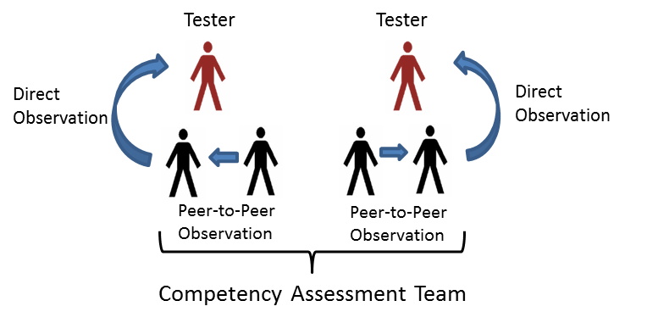

- Equipment Required
  - Computer and projector
  - Flip Chart
  - Laptop for participants
  - Android Tablets (Proposed Specifications provided below)
    - Samsung Galaxy Tab 4, storage- 8GB, screen -8”inch with at least OS 1.6 or higher
    - Bluetooth keyboard with tablet cover (make sure the tablet cover has a hole in the back to enable the use of the camera)
    - Rain protector cover/carry case
    - Same tablet and configuration for all tablets and accessories
    - If you need to use a local 3G network, ensure you purchase unlocked tablets.

REQUIREMENTS FOR EVALUATOR CERTIFICATION
The minimum acceptable scores as outlined below will be required to be considered as a certified evaluator.
Criteria | Total Points | Minimum Acceptable Score | Comments
Attendance | 10 | 100% | Mandatory attendance to all sessions
Pre training assessment | 10 | 80% | Expected to be familiar with HTS and national QA programs
Understanding of training content | 10 | 100% | Demonstrates knowledge of training content through group activities
Field Practice – Personnel Competency Assessment | 75 | 90% | Uses personnel competency assessment techniques effectively during direct observation of testing by personnel
Computer skills /data management understanding | 10 | 80% | Ability to compile and analyze evaluation data
Post training assessment | 10 | 90% | Expected to have improved knowledge on HTS and national QA programs
Total | 125

